**PIG Use Case: Pokemon Data Analysis**

 using the local mode.

Commmands:

Load_Data = LOAD ‘/home/prateek/Documents/PIG/Pokémon.csv’ USING PigStorage(‘,’) AS(Sno:int,Name:chararray,Type1:chararray,Type2:chararray,Total:int,HP:int,Attack:int,Defense:int,SpAtk:int,SpDef:int,Speed:int);

Dump;

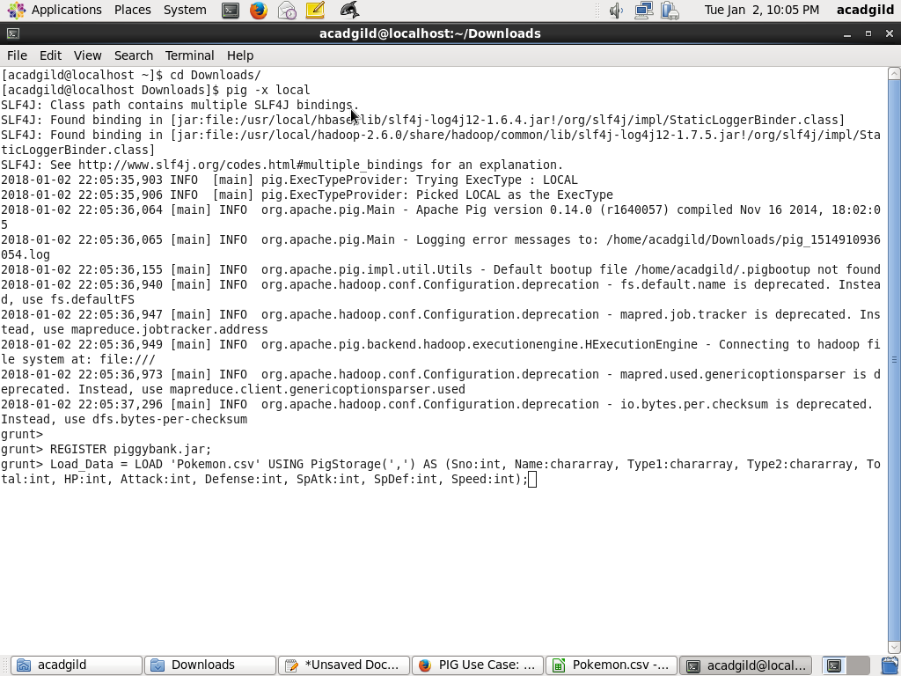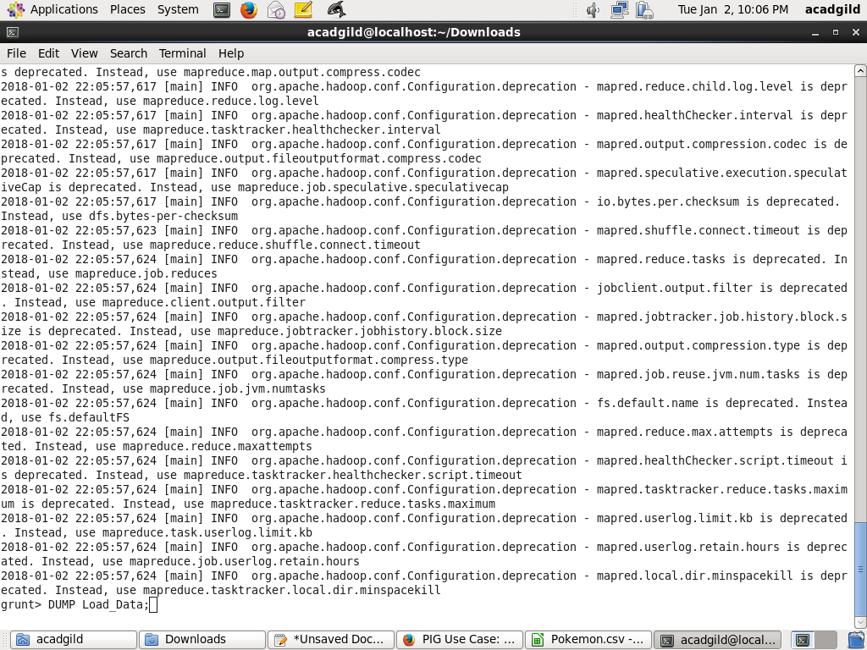

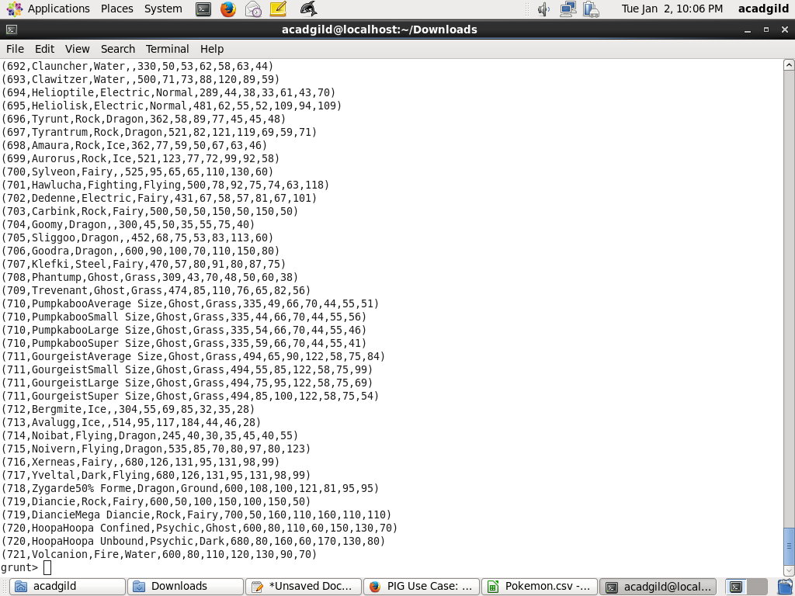

#### Ques 1: Find the list of players that have been selected in the qualifying round (DEFENCE>55).

*Command*

selected_list = FILTER Load_Data BY Defense>55;

dump;

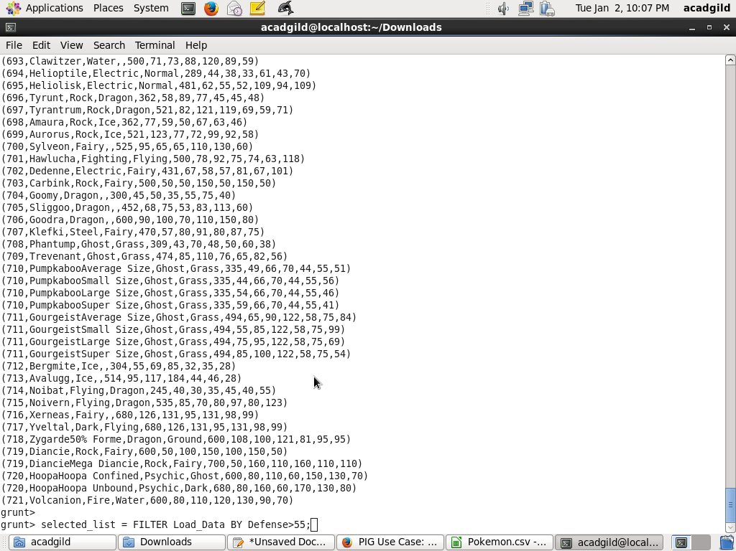

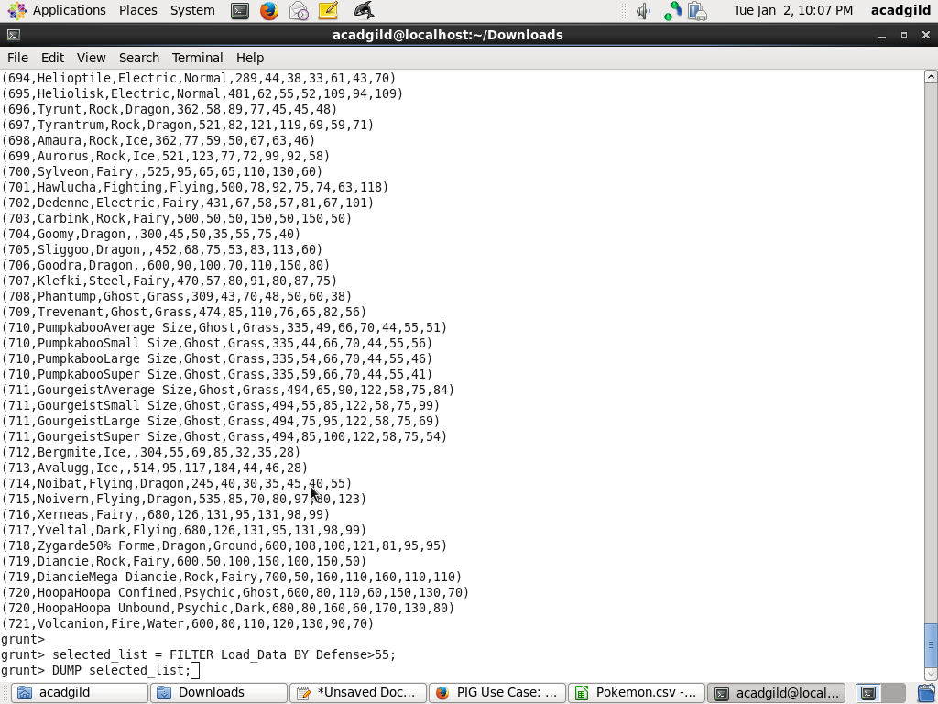

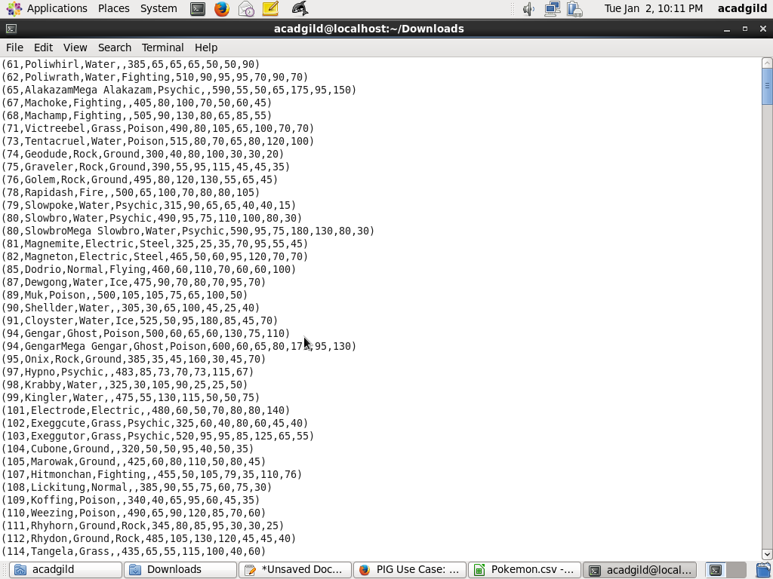

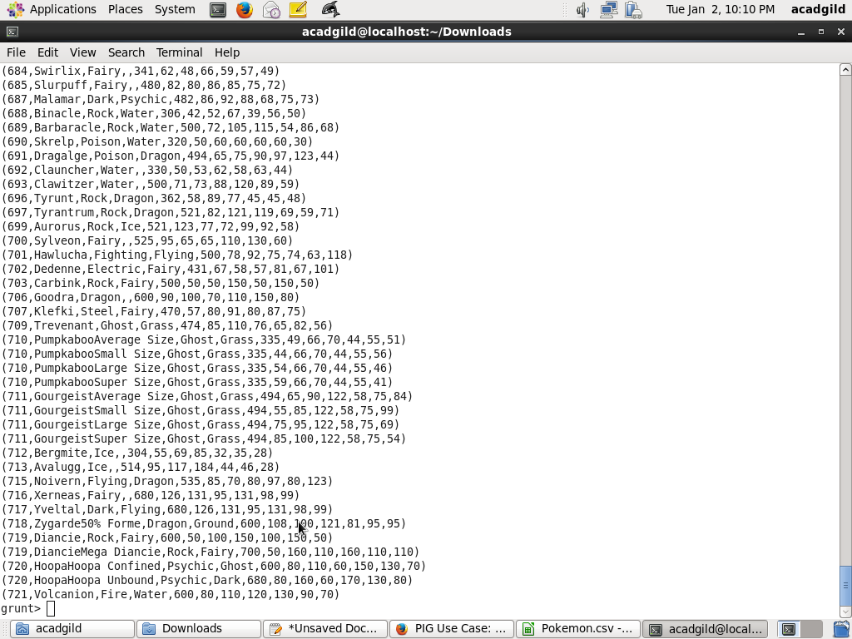

#### Ques 2: State the number of players taking part in the competition after getting selected in the qualifying round.

*ommand*

gourp_selcted_list = Group selected_list All;

count_selcted_list = foreach gourp_selcted_list GENERATE COUNT(selected_list);

dump;

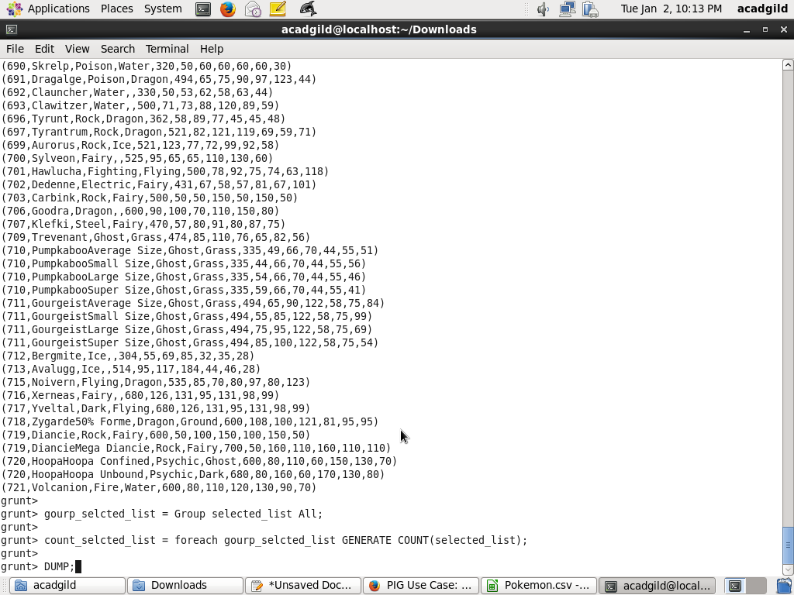

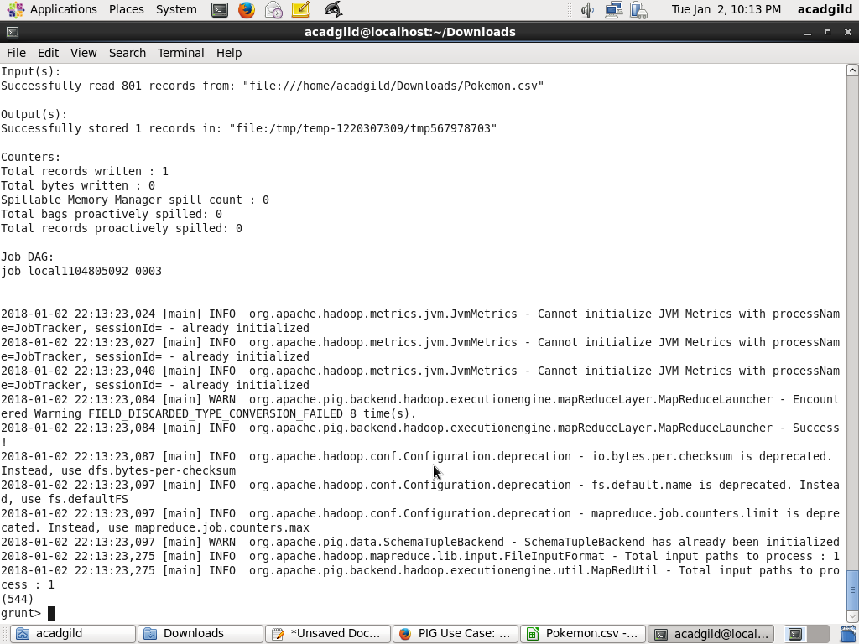

#### Ques 3: Using random() generate random numbers for each Pokémon on the selected list.

*Command*

random_include1 = foreach selected_list GENERATE RANDOM(),Name,Type1,Type2,Total,HP,Attack,Defense,SpAtk,SpDef,Speed;

dump;

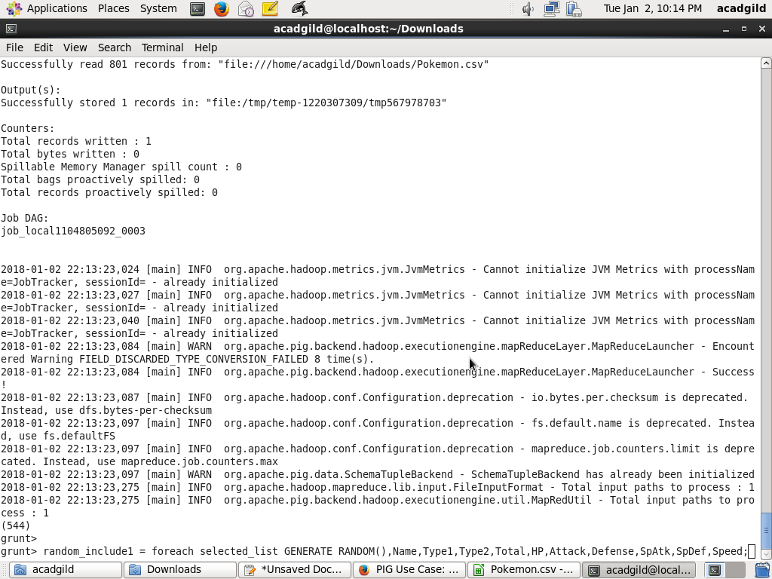

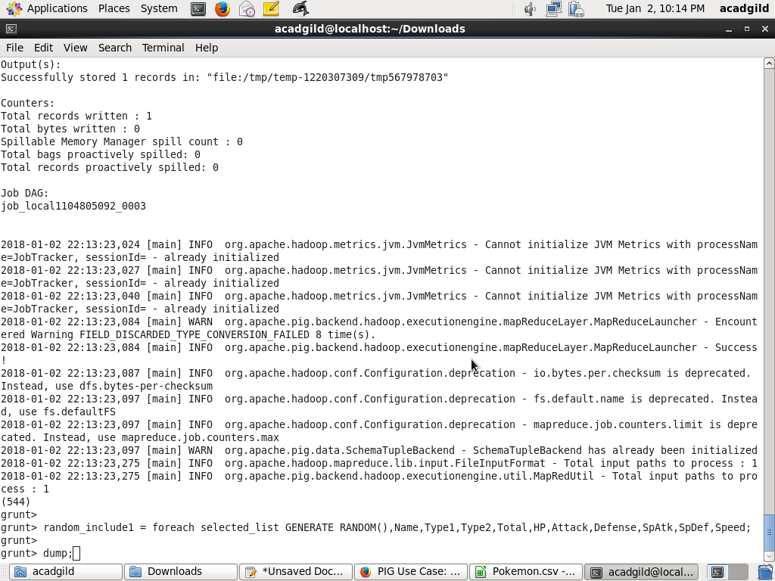

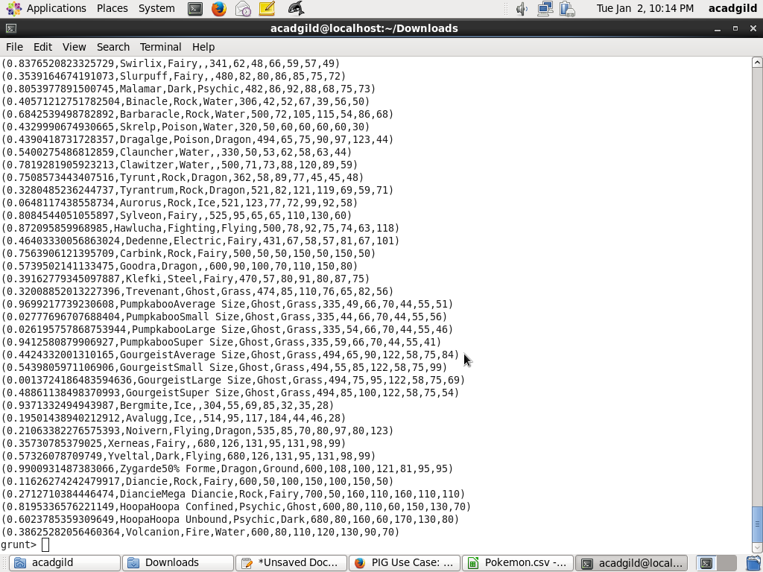

#### Ques 4: Arrange the new list in a descending order according to a column randomly.

*Command*

random1_desending = ORDER random_include1 BY $0 DESC;

dump;

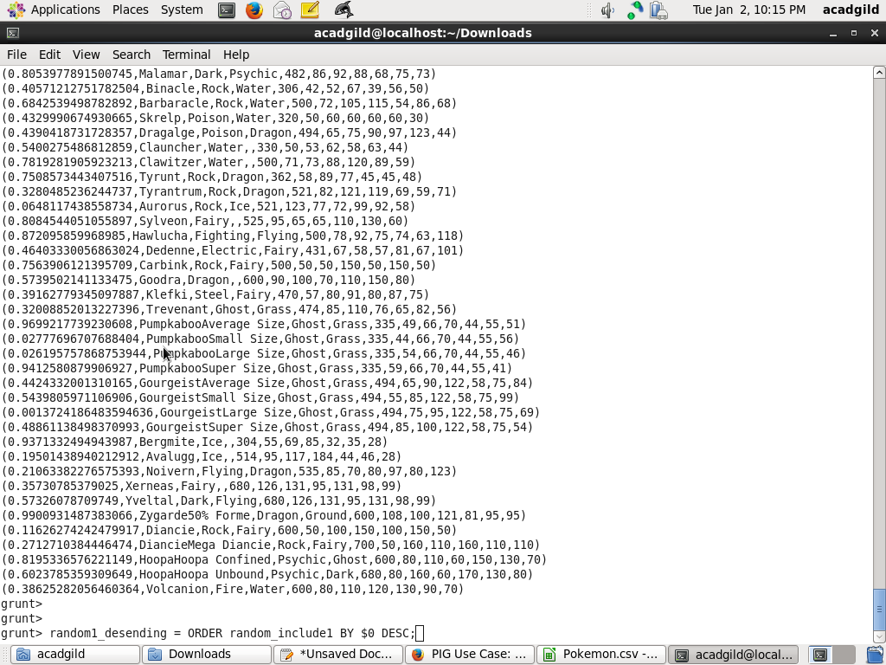

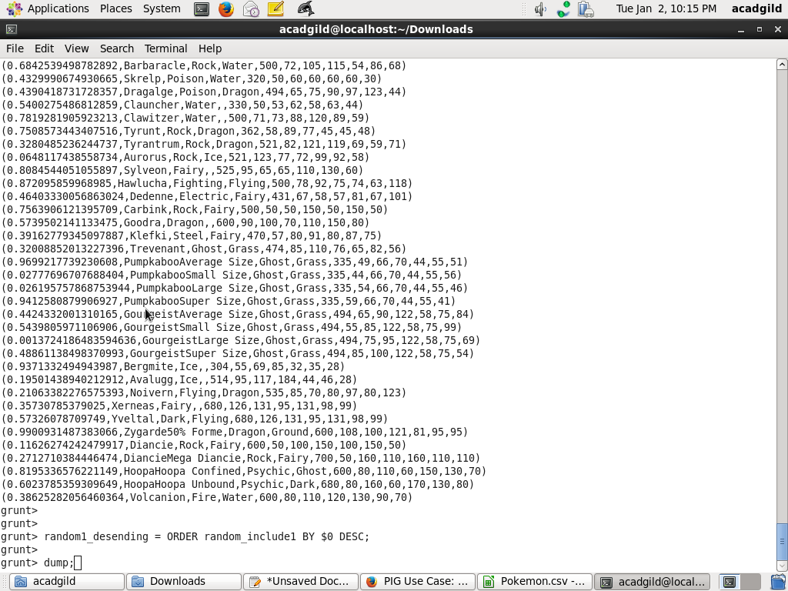

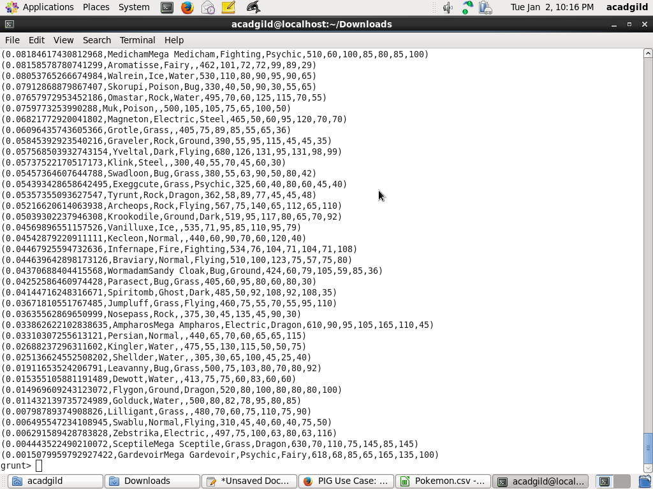

#### Ques 5: Now on a new relation again associate random numbers for each Pokémon and arrange in descending order according to column random.

*Command*

random_include2 = foreach selected_list GENERATE RANDOM(),Name,Type1,Type2,Total,HP,Attack,Defense,SpAtk,SpDef,Speed;

random2_desending = ORDER random_include2 BY $0 DESC;

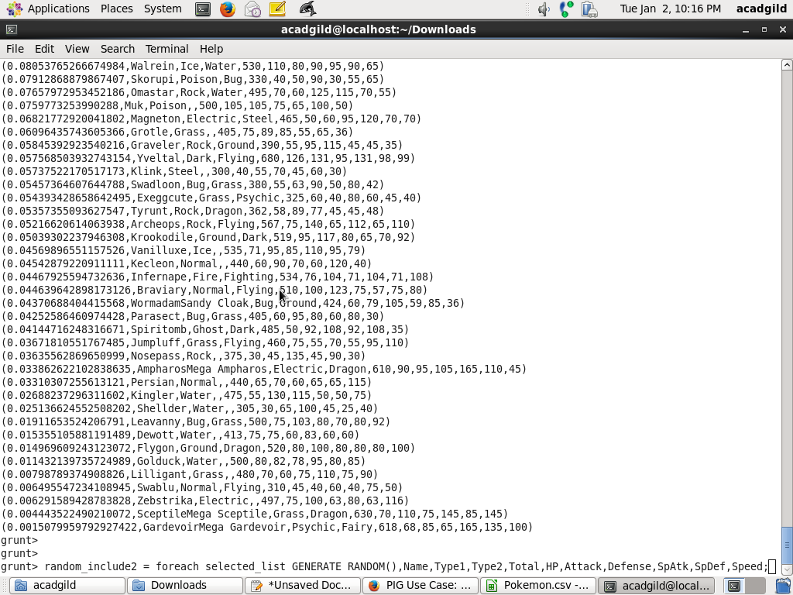

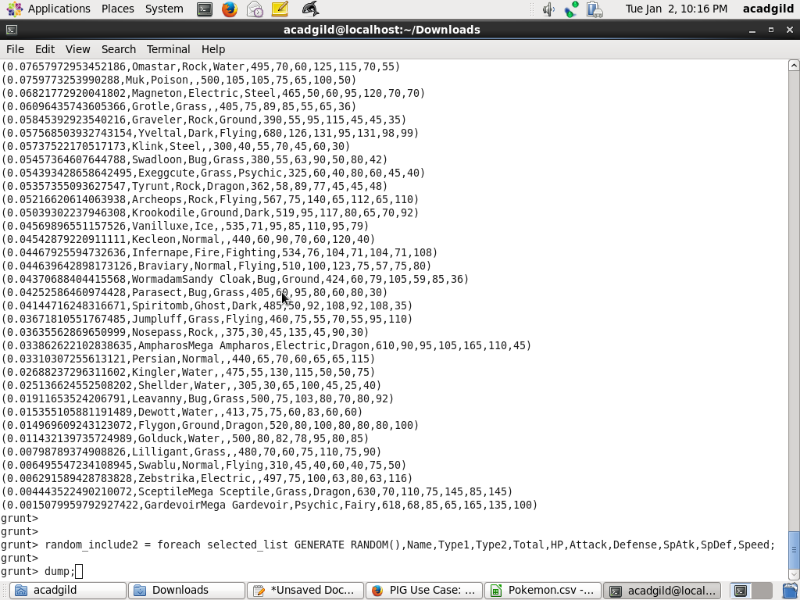

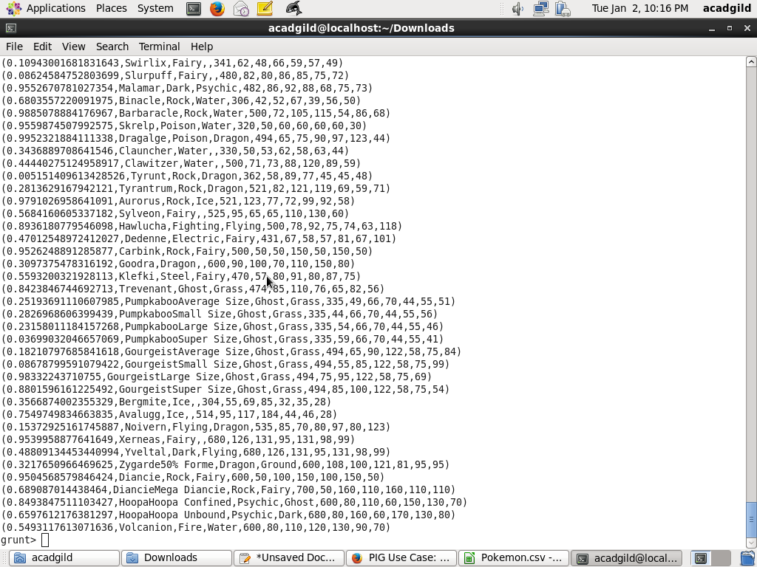

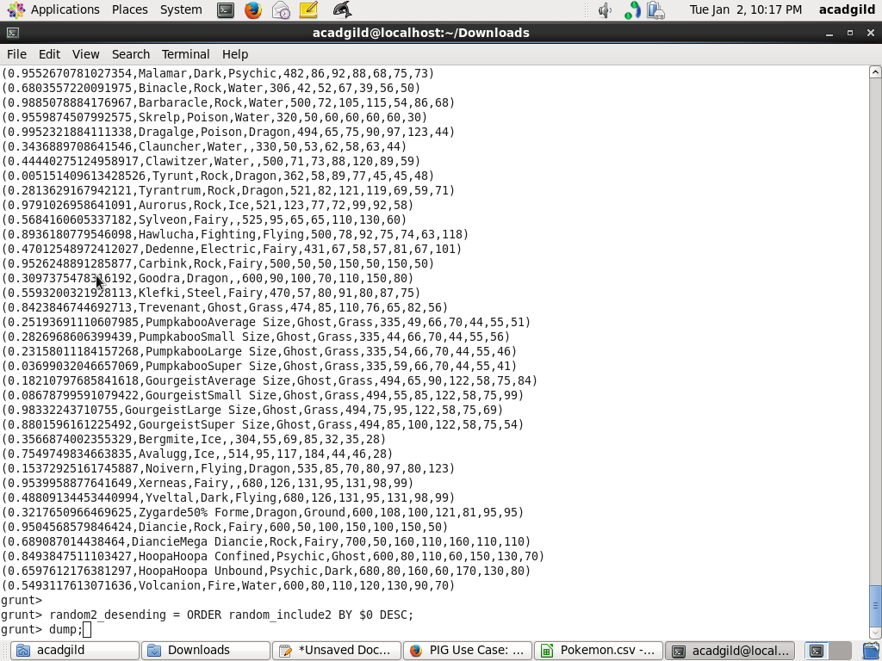

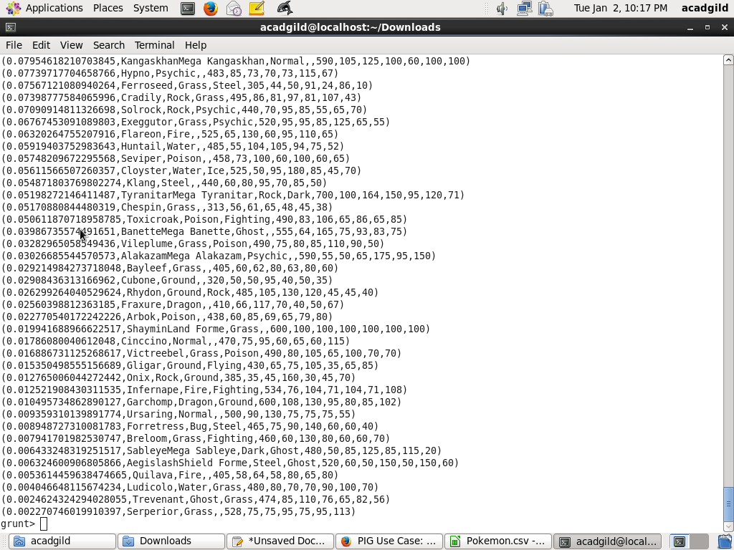

#### Ques: From the two different descending lists of random Pokémons, select the top 5 Pokémons for 2 different players.

*Commands*

limit_data_random1_desending = LIMIT random1_desending 5 ;

limit_data_random2_desending = LIMIT random2_desending 5 ;

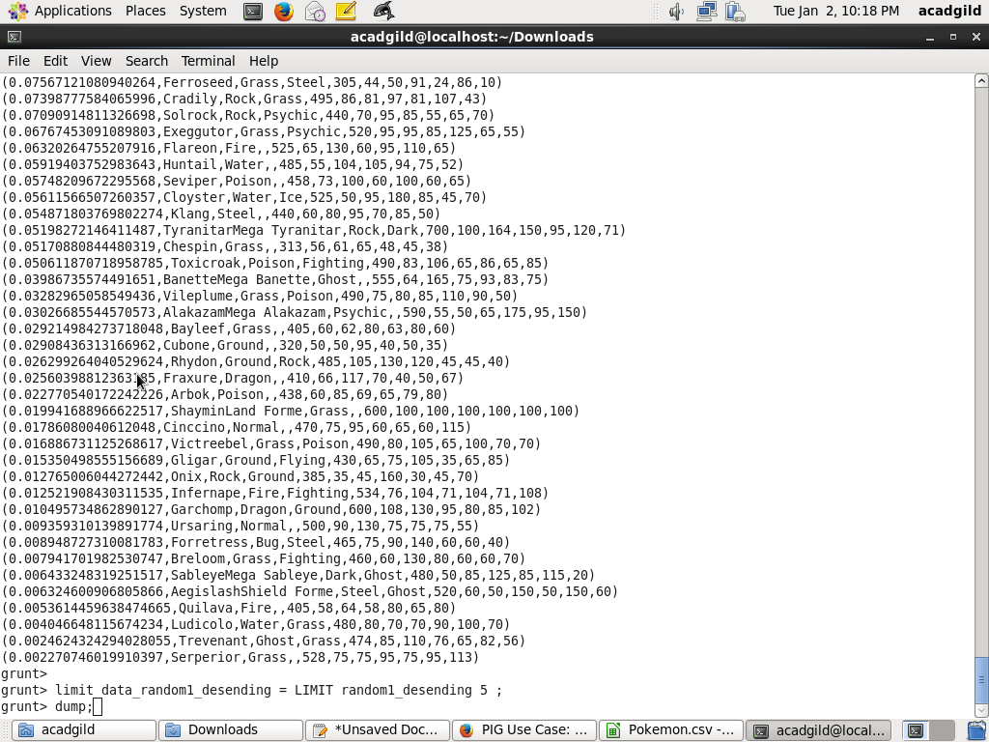

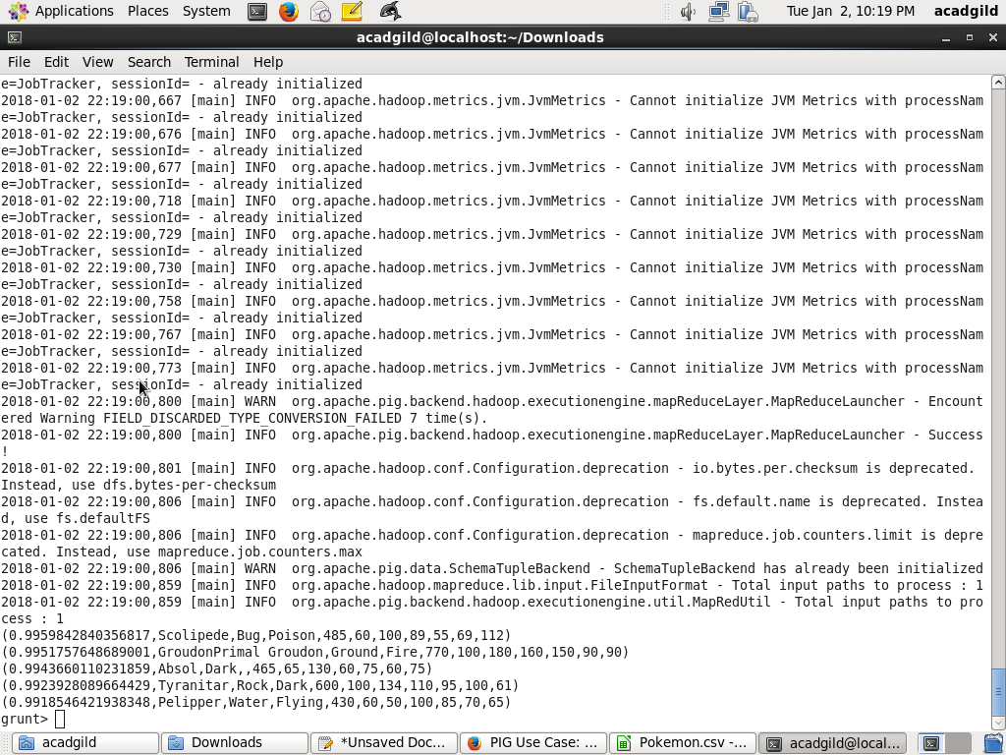

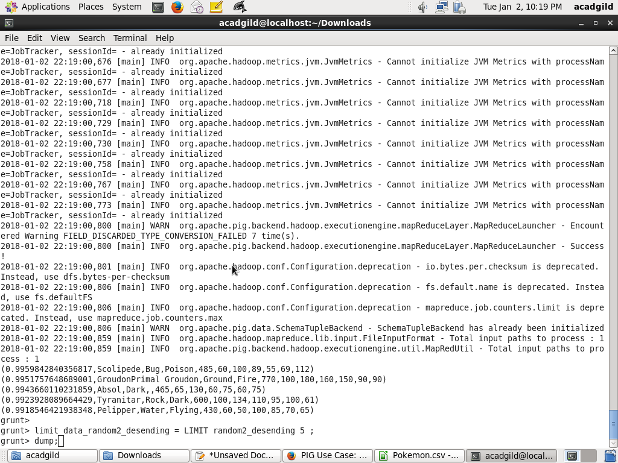

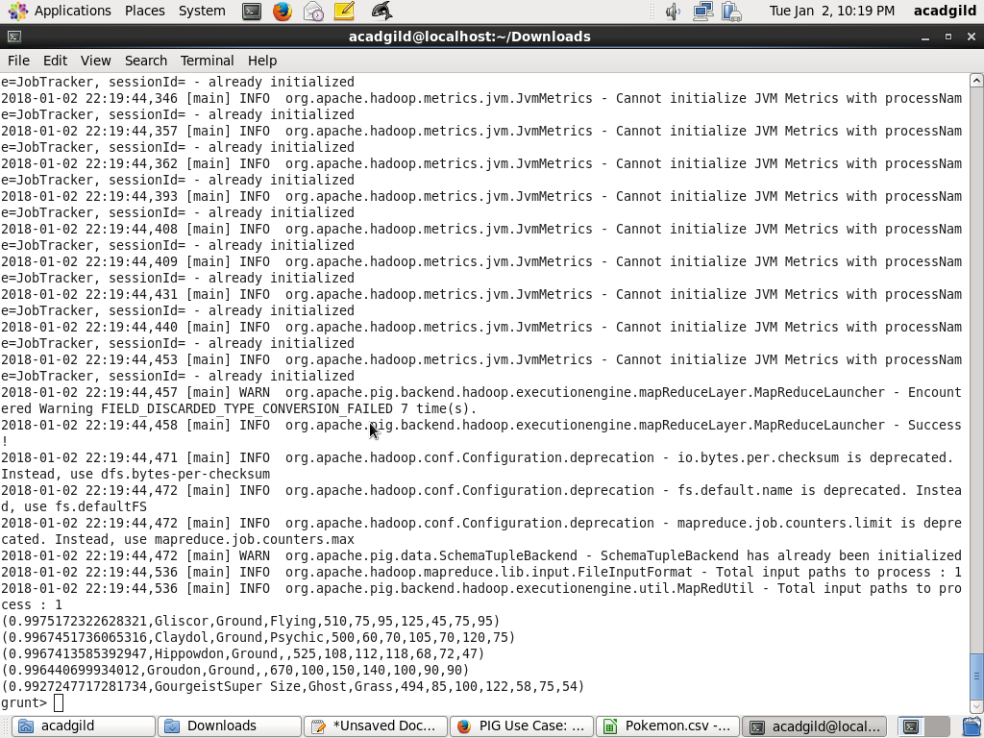

#### Ques: Store the data on a local drive to announce for the final match. By the name player1 and player2 (only show the NAME and HP).

*Commands*

filter_only_name1 = foreach limit_data_random1_desending Generate ($1,HP);

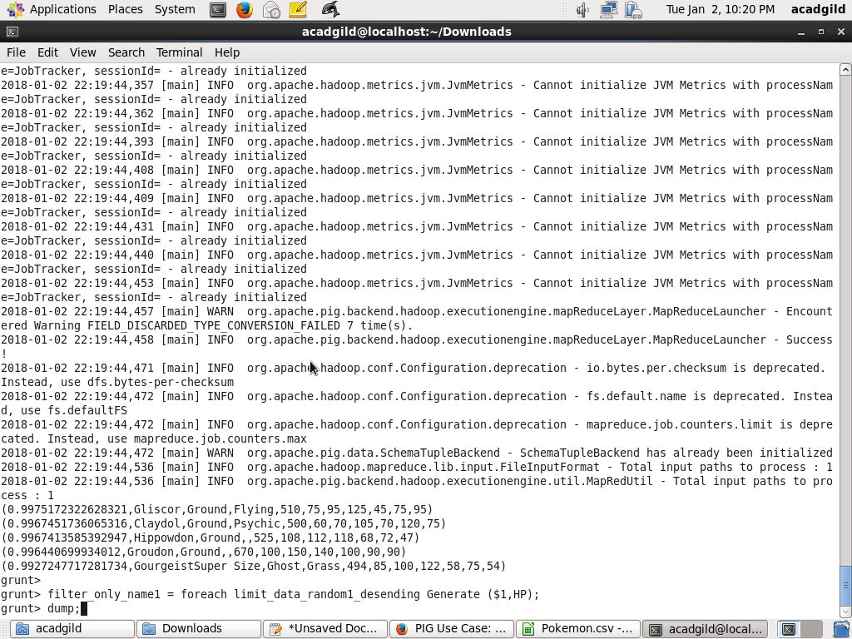

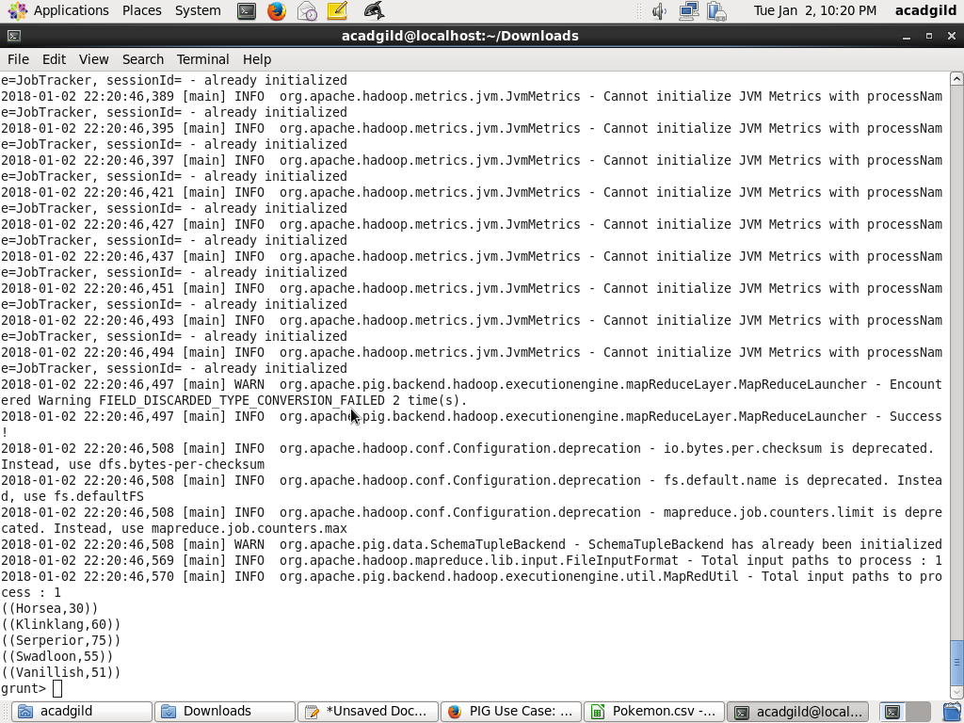

filter_only_name2 = foreach limit_data_random2_desending Generate ($1,HP);

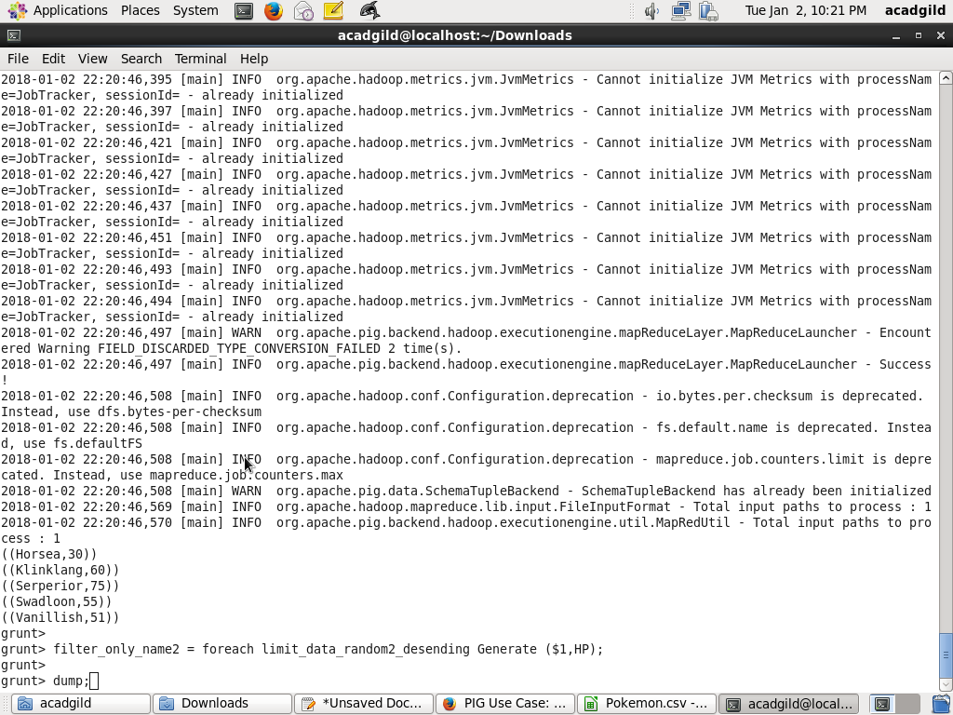

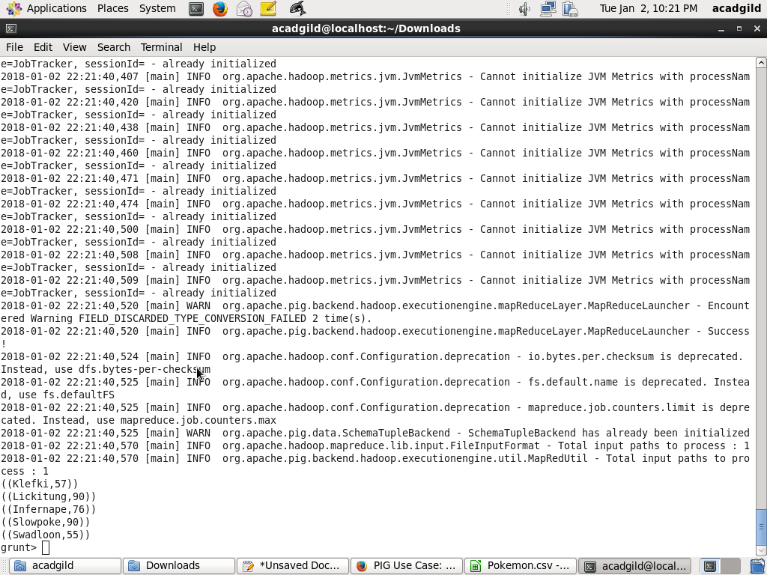

STORE limit_data_random1_desending INTO ‘/home/acadgild/Downloads/dat1.txt’;

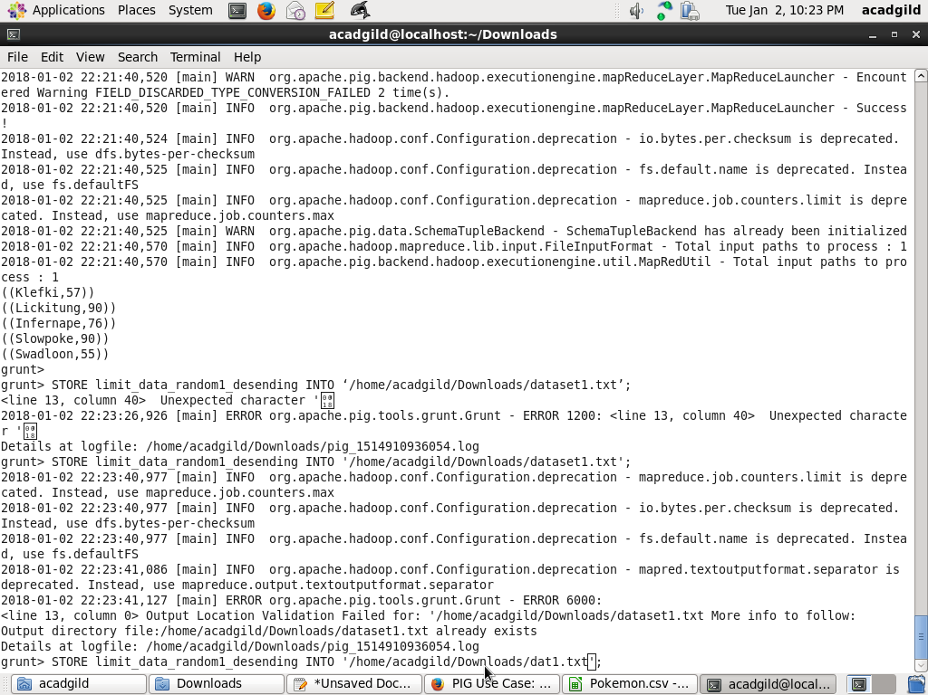

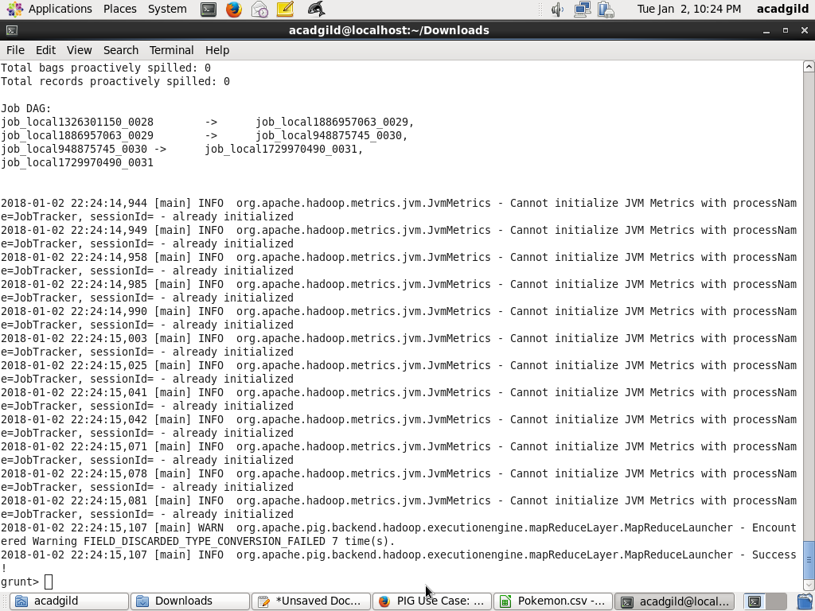

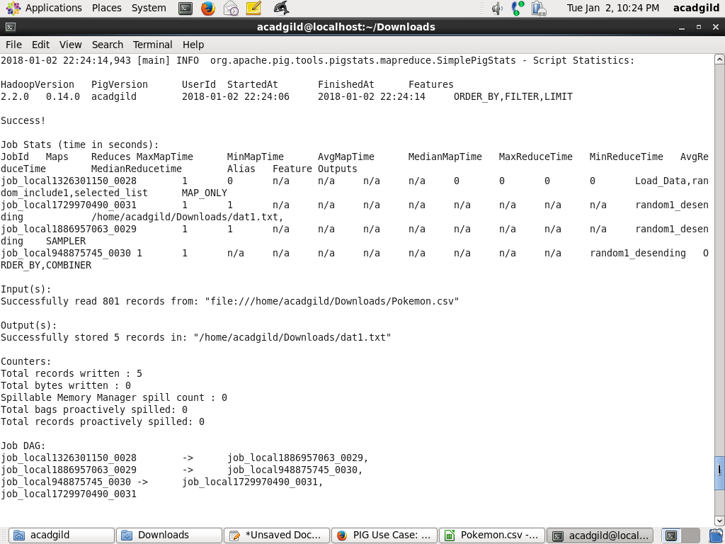

STORE limit_data_random2_desending INTO ‘/home/acadgild/Documents/prateek/PIG/player2.txt’;

